**Practical 6**

**Aim:** To implement Nested Queries

**Q**) Create a Table Employee with the following attributes Eno, Ename ,addr, salary ,department_no

Insert 5 rows any 2 employees may have the same department_no and answer the following queries :

1. Select Ename, Eno,addr from employee where salary >( select salary from employee where Ename=’Naman’;
2. Select Ename, Eno, from employee where salary < any( select salary from employee where department_no=’1’
3. Select * from employee X where X.Salary > (select avg(salary) from employee where department_no= X.department_no

**Answers :**

**Step 1: Create the Table Employee**

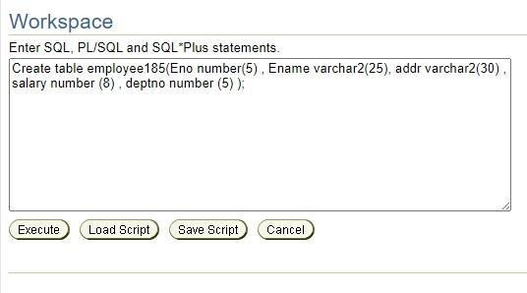

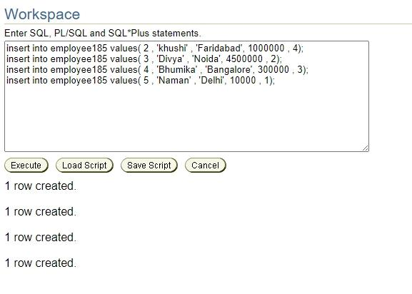

**Step2: Insert the values in the table**

**Step 3: Now perform the following queries**

1. SELECT ENO,ENAME,ADDR FROM enployee185 WHERE SALARY > (SELECT SALARY FROM EMPLOYEE WHERE ENAME=’Naman’);

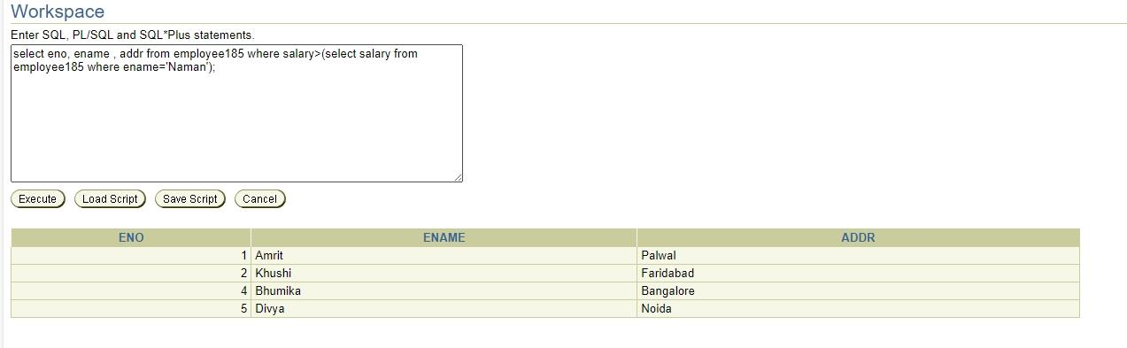

1. SELECT ENAME, ENO FROM employee185 WHERE SALARY < (SELECT SALARY FROM EMPLOYEE WHERE deptno='1’);

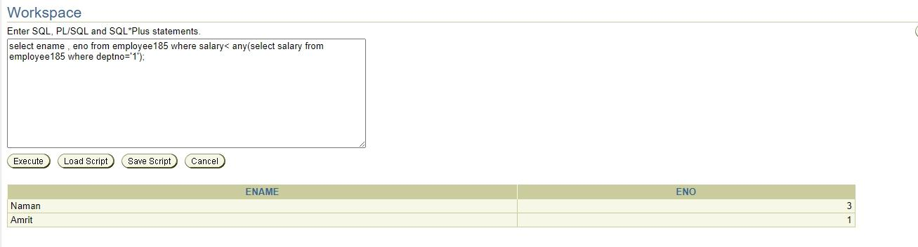

1. SELECT * FROM enployee185 X WHERE X.SALARY > (SELECT AVG(SALARY) FROM EMPLOYEE WHERE deptno=X.deptno);

